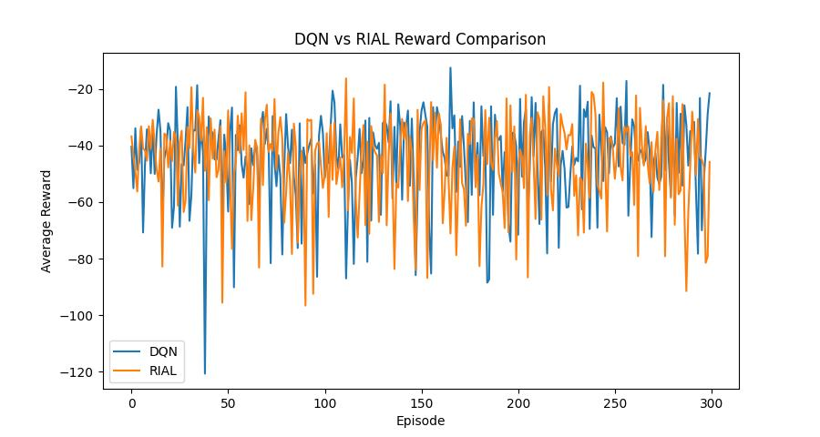

**Result Analysis: DQN vs RIAL**

#### ****1. Learning Speed****

In the early episodes, both DQN and RIAL improve quickly. However, DQN shows a slightly faster rise in average reward during the first 30–50 episodes.  
→ DQN learns a bit faster in this environment.

#### ****2. Stability****

Throughout training, DQN's reward curve has slightly less fluctuation compared to RIAL. RIAL shows some sharp drops, especially around episodes 90, 150, and 280.  
→ DQN is more stable overall.

#### ****3. Final Performance****

The bar chart shows the average reward over the last 50 episodes. DQN performs slightly better than RIAL.  
→ DQN has better final performance in this experiment.

#### ****4. Cooperation****

There is no clear sudden increase in RIAL’s reward that suggests successful communication between agents. The curve grows slowly and remains similar to DQN’s.  
→ RIAL doesn’t show obvious cooperation benefits here.

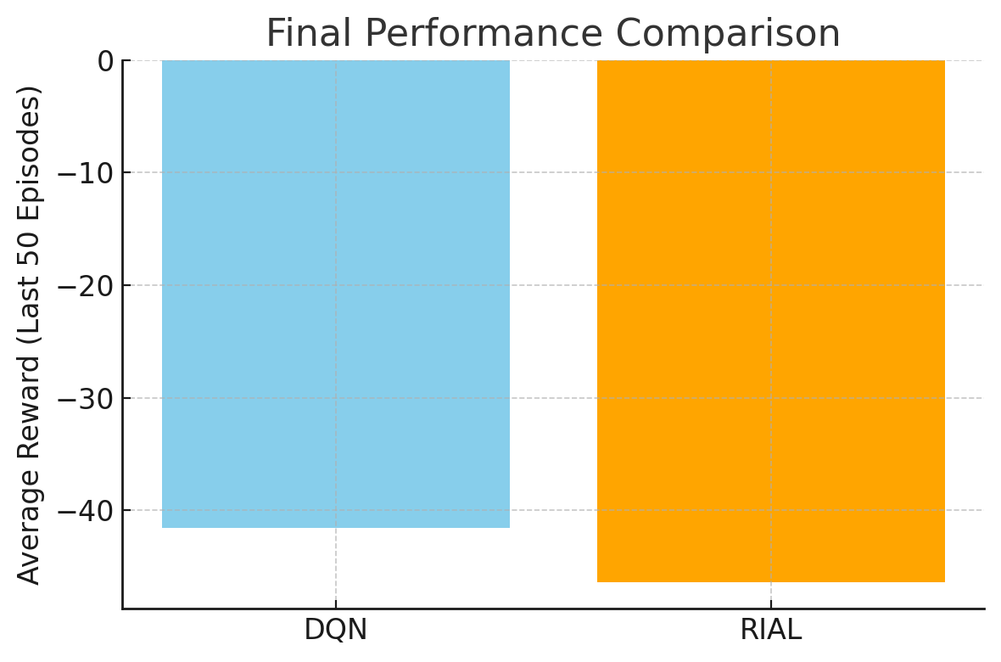**Bar Chart Meaning**

The bar chart compares the **final performance** of DQN and RIAL by showing the average rewards of the last 50 episodes. It helps to summarize and visualize how well each method performs after learning.  
In the chart, **DQN has a higher average reward**, meaning it learned a slightly better strategy in this setting.

**Further Explanation**

Although RIAL is designed for agent communication, in this code the message input is always set to 0 and not truly exchanged between agents. As a result, RIAL does not gain any real advantage from communication.

Meanwhile, DQN is simpler and more stable, and the task itself (simple_spread_v3) does not require strong cooperation. So DQN ends up performing slightly better in this case.